



PROJECT TITLE: CREATION OF AN APPLICATION FOR SCHOOL MANAGEMENT – ADMIN

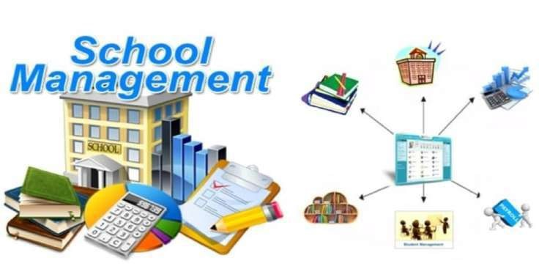

# Presented by

TeamId: LTVIP2023TMID06123

Team Leader: Shaik Ruksana (208x1a05g1@khitguntur.ac.in)

Team Member 1: Balineni Srilakshmi(208x1a05c8@khitguntur.ac.in)

Team Member 2: Kambhampati Akhil(208x1a05e7@khitguntur.ac.in)

Team Member 3: Maddu Ramya (208x1a05f2@khitguntur.ac.in)

Team Member 4: Chalamalasetty Keerthana(208x1a05d6@khitguntur.ac.in)

Team Member 5: Rentapalla Vamsi (218x5a0208@khitguntur.ac.in)

## INTRODUCTION

***Overview:***

The project "Creation of an Application for School Management - Admin" in Salesforce aims to develop a comprehensive and customizable cloud-based solution for managing various administrative tasks in educational institutions. Leveraging Salesforce's powerful platform and tools, the application will streamline and automate administrative processes, improving efficiency and data management.

***Purpose:***

1.The project aims to develop an application for school management that automates administrative tasks, enhancing efficiency and reducing manual effort.

2.It centralizes student, teacher, and staff information, ensuring better data management and accuracy in records.

3.The application fosters seamless communication between teachers, parents, students, and administrators through announcements and notifications.

4.It simplifies attendance tracking, academic performance monitoring, and examination/result management for teachers and administrators.

5.The application provides valuable reports and analytics to aid data-driven decision-making for improved school performance and resource management.

### LITERATURE SURVEY

***Existing Problem:***

1.The existing problem with the creation of an application for school management is the lack of a unified and efficient system to handle various administrative tasks.

2.Many schools still rely on manual processes, spreadsheets, and disparate software, leading to inefficiencies, data inconsistencies, and communication gaps.

3.This fragmented approach often results in difficulties in tracking attendance, managing student information, generating accurate reports, and ensuring smooth communication among teachers, parents, and administrators.

4. The absence of a comprehensive and user-friendly school management application hampers the overall efficiency and effectiveness of school operations.

***Proposed Solution****:*

1.The proposed solution to suggest is to develop a comprehensive cloud-based school management application with an intuitive interface, automation features, and seamless integration.

1. It will facilitate efficient attendance tracking, academic management, and communication among teachers, parents, students, and administrators.
2. The application will provide valuable insights through analytics and reports, ensuring datadriven decision-making.
3. With robust security measures and customization options, schools can enhance overall efficiency and productivity, creating a more streamlined and effective learning environment.

THEORITICAL ANALYSIS Block Diagram:

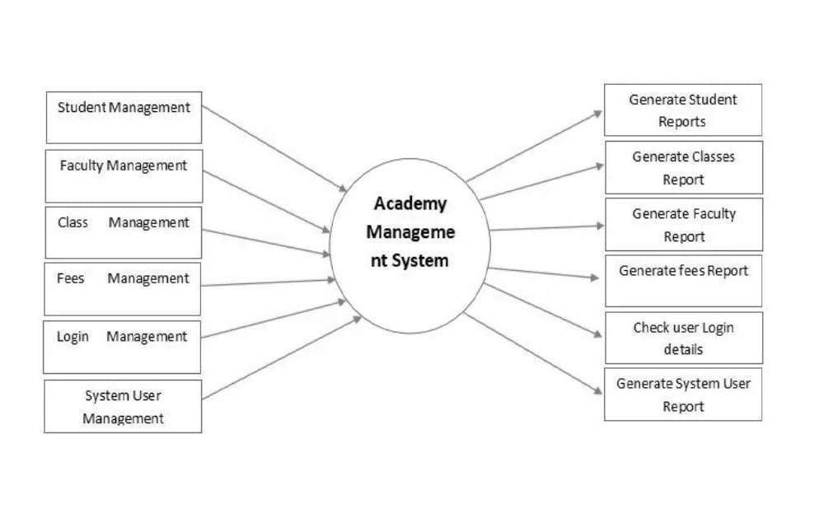

***Hardware and Software Designing:***

In the Salesforce platform, the School Management Application would be developed as a cloud-based software solution, which means most of the hardware requirements would be taken care of by Salesforce itself. However, there are still some essential hardware and general requirements to consider:

**Hardware Requirements:**

1.Client Devices: Users will need computers, laptops, or mobile devices with internet connectivity to access the application.

2.Internet Connection: A stable and reliable internet connection is necessary for seamless access to the Salesforce platform and the application.

**Salesforce Platform Requirements**:

1.Salesforce Account: You will need a Salesforce account to develop and host the application.

2.Edition: The edition of Salesforce used will depend on the requirements and complexity of the application. Options include Salesforce Essentials, Professional, Enterprise, or Unlimited editions.

3.Licenses: Sufficient user licenses must be available for administrators, teachers, students, and parents, as per the number of users who will access the application.

**Salesforce Limits and Allocations:**

1.API Limits: The application's integration with external systems may require consideration of API limits imposed by Salesforce.

2.Data Storage: Depending on the volume of data, you may need to ensure sufficient data storage is available in your Salesforce org.

3.Custom Objects and Fields: If the application involves custom objects and fields, ensure that they fit within Salesforce's object and field limits.

**Security and Compliance**:

1.Data Privacy: Implement proper security measures to ensure data privacy and comply with relevant regulations, such as GDPR (General Data Protection Regulation).

2.User Authentication: Enable secure login mechanisms like multi-factor authentication to protect user accounts.

**Customization and Development**:

1.Development Environment: Use a suitable development environment to build custom Visualforce pages, Lightning components, and Apex classes to tailor the application to your specific needs.

2.Integration Requirements: Determine the need for integrating with other systems and ensure compatibility and security.

**User Training and Support**:

1.User Training: Provide training and documentation to users to ensure they understand how to use the application effectively.

2.Technical Support: Have a support mechanism in place to address any issues or queries that users may encounter.

PROCESS AND RESULTS

**1.Creating Developer Org:**

Creating a developer org in salesforce

1. Go to [developer.salesforce.com](https://developer.salesforce.com/)
2. Click on sign up.
3. On the sign up form, enter the following details
4. First name & Last name
5. Email
6. Role – Administrator
7. Company - College Name
8. Country – India
9. Postal Code - pin code
10. Username- should be a combination of your name and company

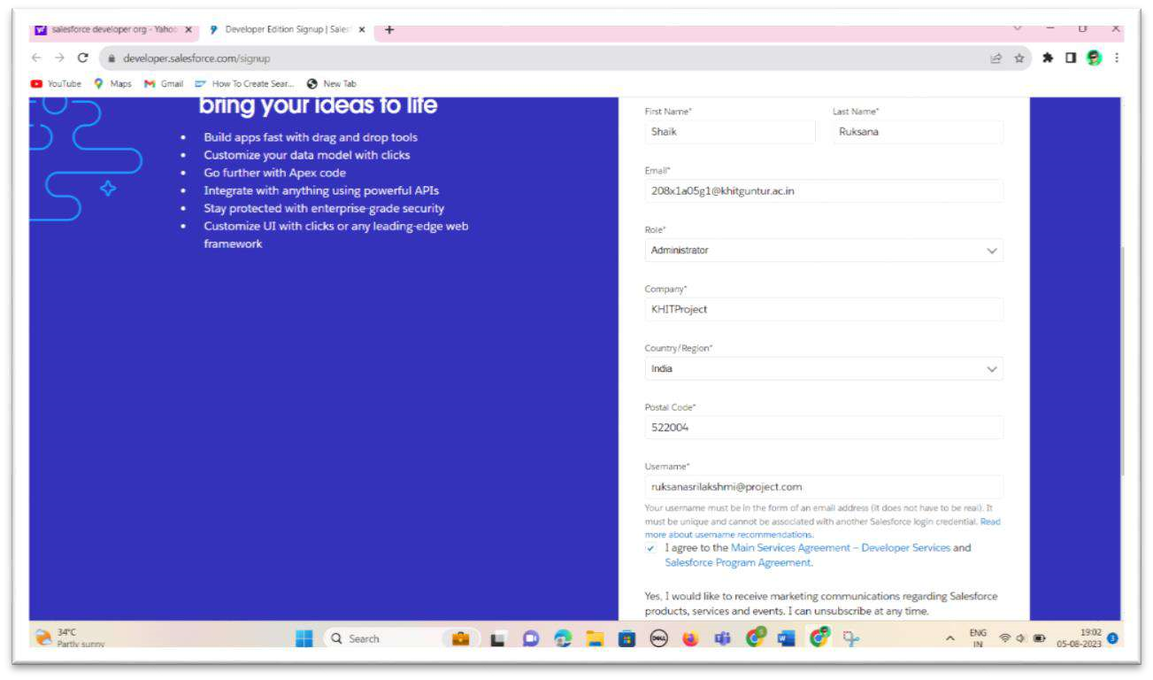

2.**AccountActivation**:

We have to verify our email to activate the account.So, click on verify account to activate the Salesforce Account

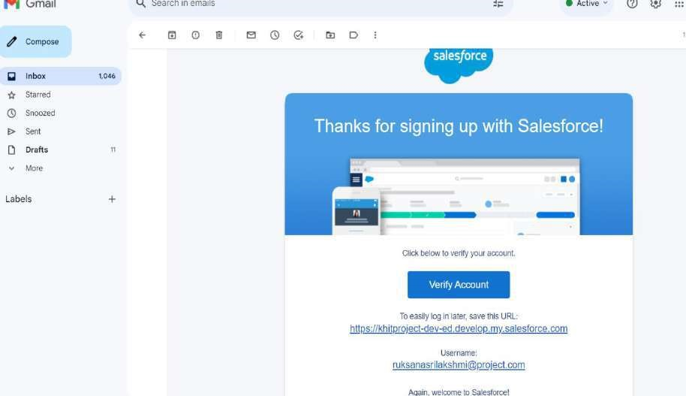

After verifying,it asks to set up the password including a security question like below:

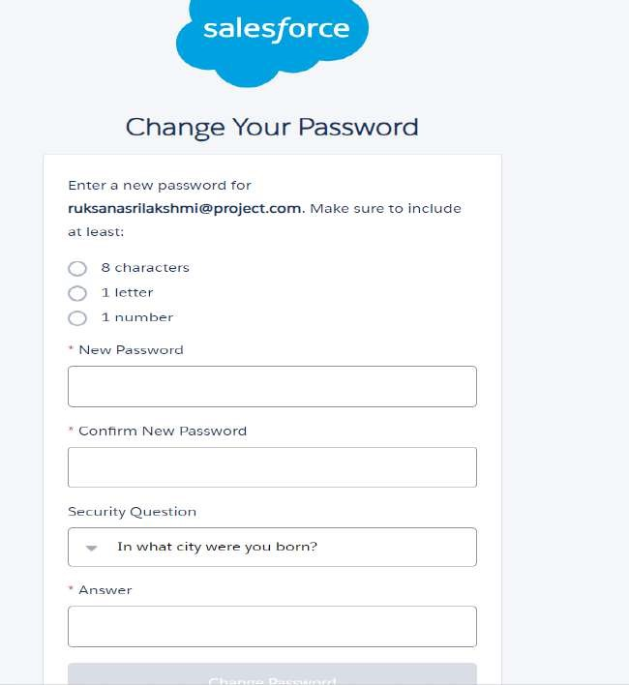

After setting the password, the page redirects to the Salesforce Setup Page where we are going to do each and every step regarding our project.Itlooks like this.

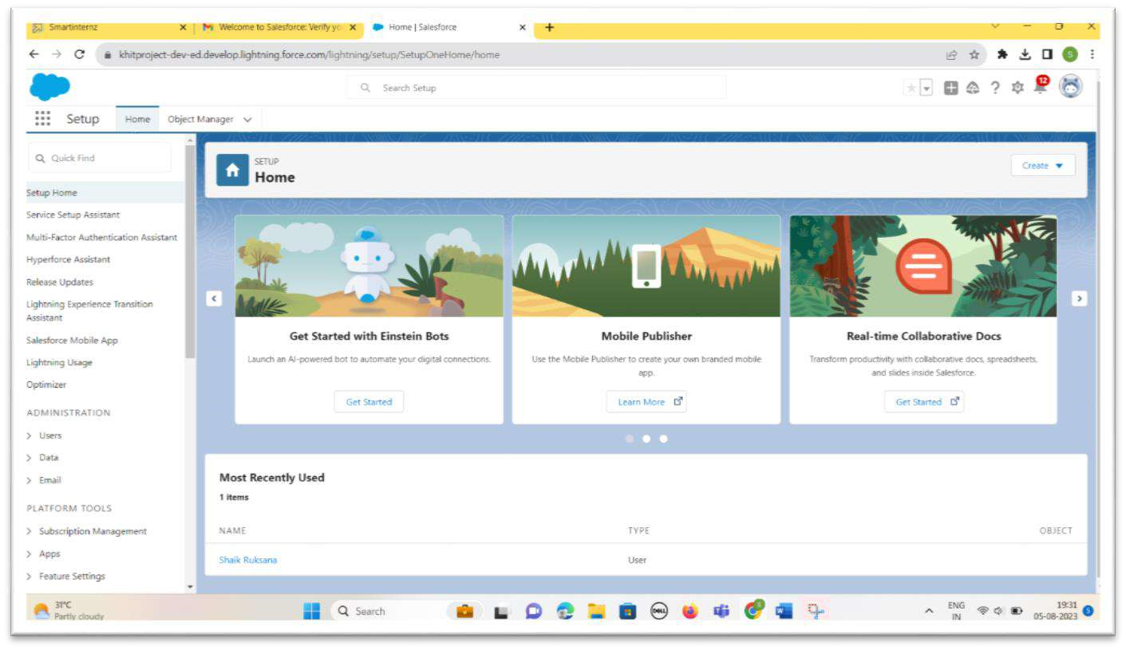

Here's a brief introduction to the key components of the Salesforce setup page:

1.Home: The central hub for Salesforce administrators to access and manage all setup options.

2.Object Manager: Customize and manage standard and custom objects, defining data structure and relationships.

3.App Launcher: Easily switch between Salesforce apps and custom-built applications.

### 3.OBJECT

Salesforce objects are database tables that permit you to store data that is specific to an organization. Salesforce objects are of two types:

* Standard Objects: Standard objects are the kind of objects that are provided by salesforce.com such as users, contracts, reports, dashboards, etc.
* Custom Objects: Custom objects are those objects that are created by users. They supply information that is unique and essential to their organization. They are the heart of any application and provide a structure for sharing data.

**Coming to our project we have to create three custom objects:**

1.School Object

2.Student Object

3.Parent Object

Goto Object Manager and select Custom Object New and Create three objects First Object – School

* 1. Label: School
  2. Plural Label: Schools
  3. Record Name: School Name
  4. Check the Allow Reports checkbox 5. Check the Allow Search checkbox

6. Click Save.

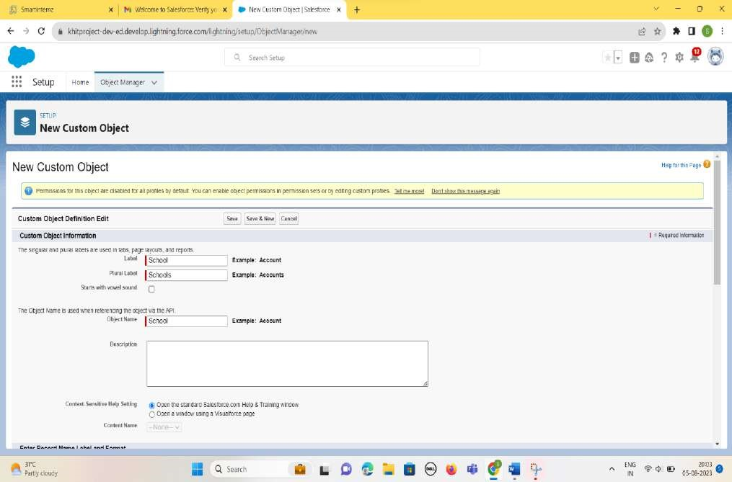

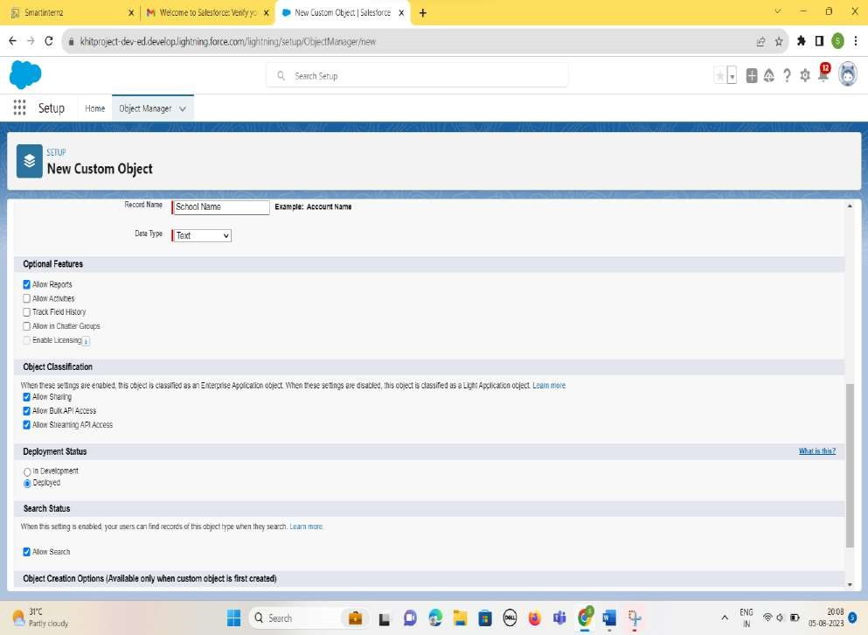

Now create a custom tab. Click the Home tab.

Search for Tabs Then Click it -→ Custom Tab→ New

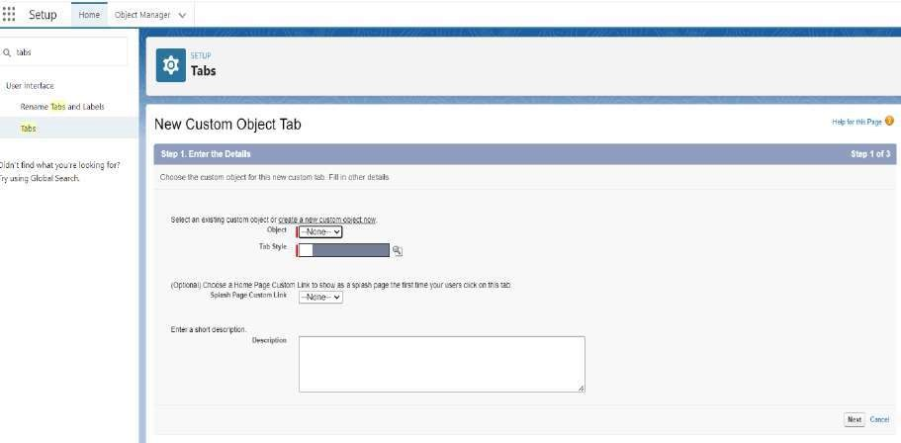

Select Object as School. And any Tab style. Click Next, Next and then Save. It looks like this.

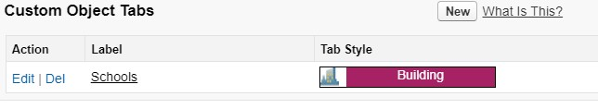

In the same way,we created the two Custom objects like Student Object and Parent Object and their respective tabs as below:

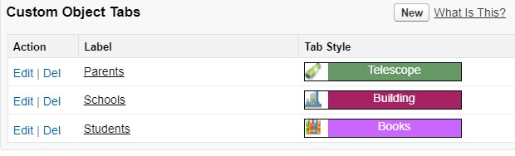

**4.Creating the Lightning App**

Apps in Salesforce are a group of tabs that help the application function by working together as a unit. It has a name, a logo, and a particular set of tabs. The simplest app usually has just two tabs.

There are two types of app -

***1. Standard App***: Standard apps come with every occurrence of Salesforce as default. Many features like Sales, Marketing, Community, call center, content, Salesforce Chatter, App

Launcher, etc are present in it.

***2.Custom Apps***: Custom apps are created according to need of user. Custom Apps are made by using standard and custom tabs together.

1. From Setup, enter App Manager in the Quick Find and select App Manager.
2. Click New Lightning App.
3. Enter School Management as the App Name, then click Next 4. Under App Options, leave the default selections and click Next.
4. Under Utility Items, leave as is and click Next.
5. From Available Items, select Schools, Students, Parents, Reports, and Dashboards and move them to Selected Items. Click Next.
6. From Available Profiles, select System Administrator and move it to Selected Profiles.Click Save & Finish.

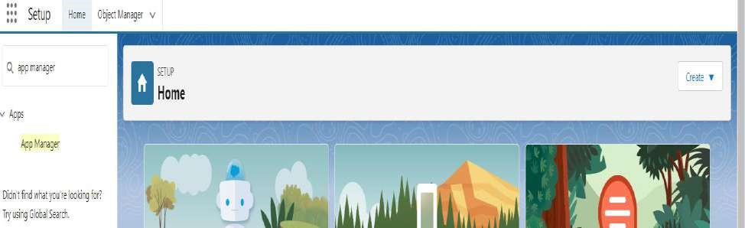

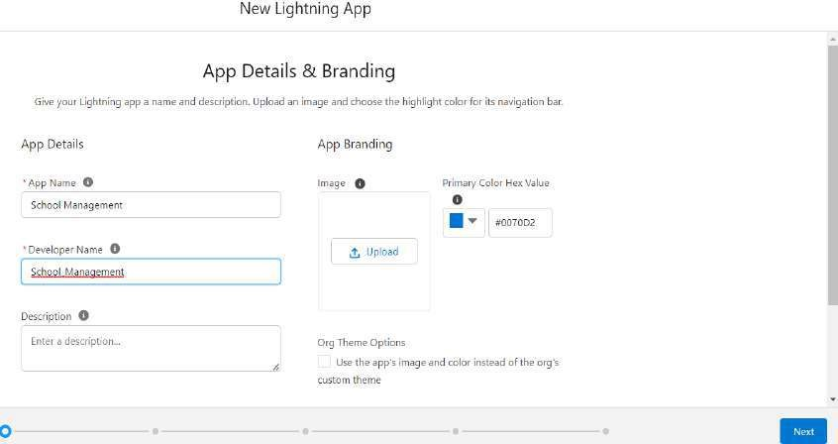

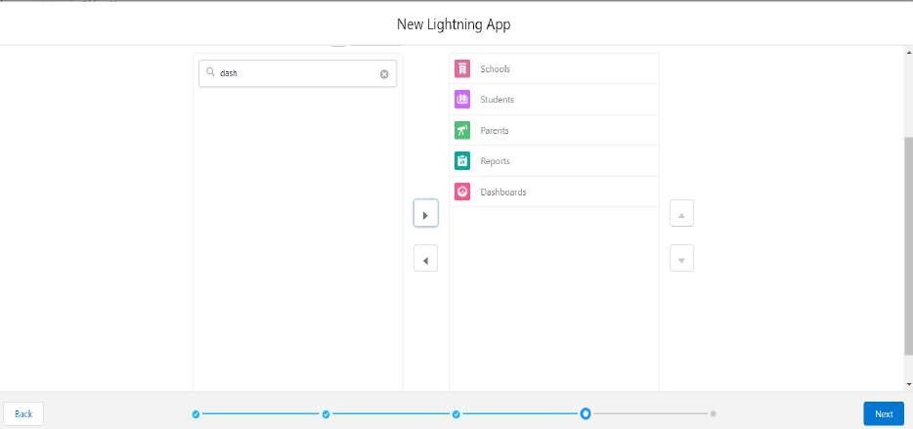



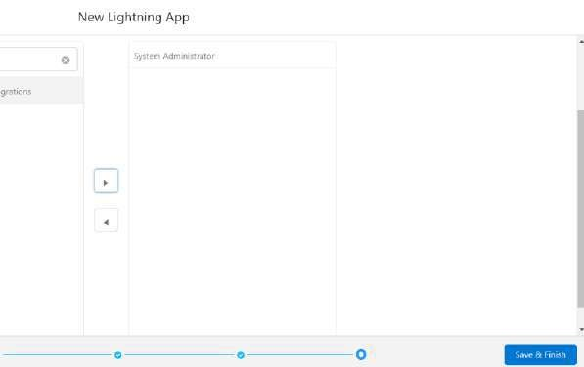

If we want to check the app we have created .Goto App Launcher→Search for the School Management App→Click it. The App looks like this.

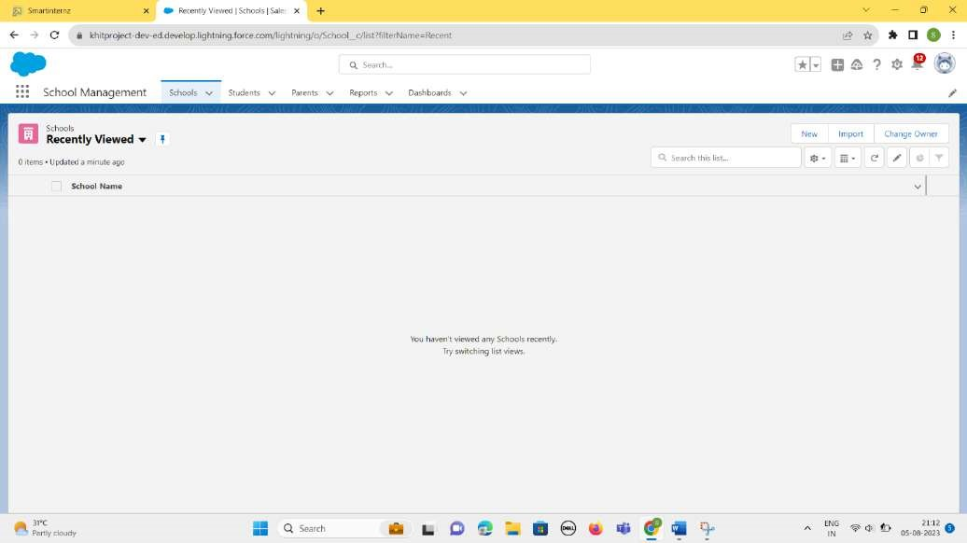

**5.Fields and Relationship**

An object relationship in Salesforce is a two-way association between two objects.

Relationships are created by creating custom relationship fields on an object. This is done so that when users view records, they can also see and access related data.

Creation Of Fields for The School Object:

* 1. Click the gear icon and select Setup. This launches Setup in a new tab.
  2. Click the Object Manager tab next to Home.
  3. Select School.
  4. Select Fields & Relationships from the left navigation
  5. Click New
  6. Select the Text Area as the Data Type, click Next.
  7. For Field Label, enter Address.
  8. Click Next, Next, then Save & New.
  9. Follow steps 1 to 3 and create two more Text type field - District & State.
  10. Create URL type field & give School website as the field label.

We have to create 5 fields for the School Object. They are – *Address, District, State*, *Phone, URL* with their respective Relationships.

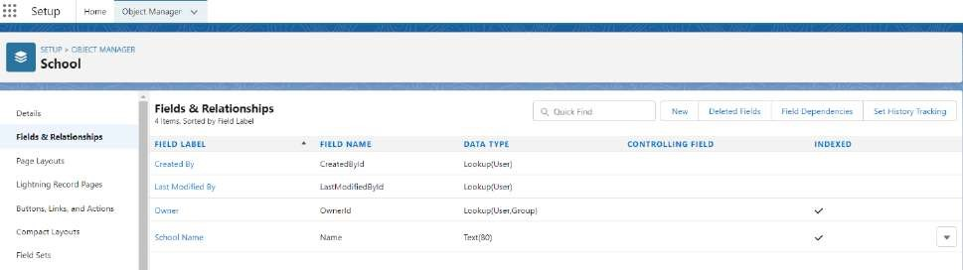

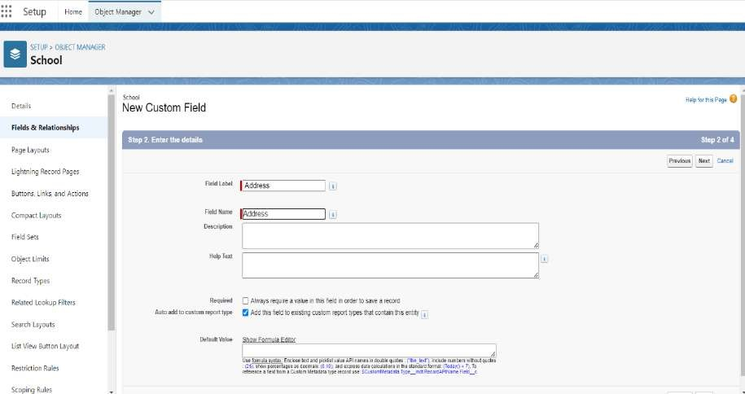

After creating all the required fields for the School Object

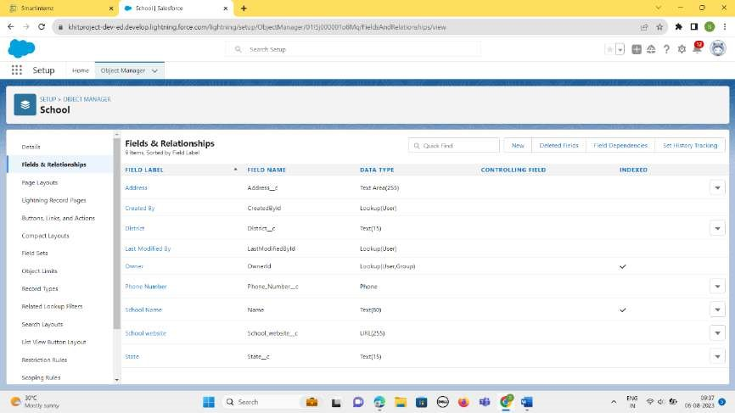



Creation Of Fields for The Student Objects:

Field 1 – *Results* and Relationship is of Picklist type and we have to enter the picklist values as Pass, Fail.

Field 2-*Class* and Relationship is of Number type

Field 3-*Marks* and Relationship is of Number type

Field 4- *Number of Students* and Relationship is of Roll-up Summary type After creating the required above fields looks like this

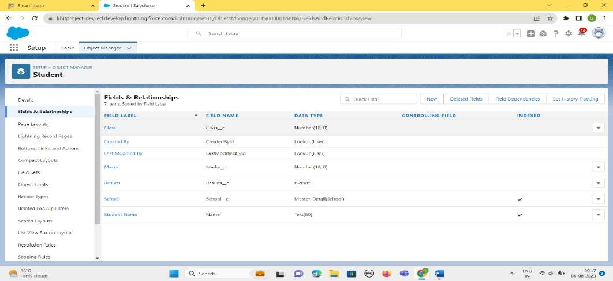

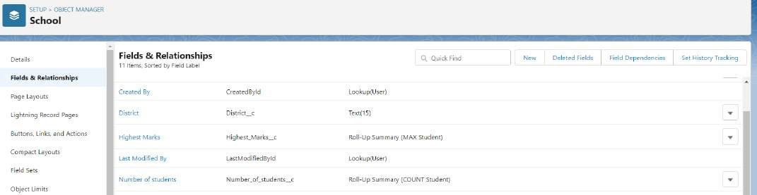

Creation Of Fields for The Parent Objects:

We have to create 2 fields

Field1 – *Parent Address*and relationship is of Text area Field2- *Parent Number*and relationship is of Phone.

After creating the above two fields, it looks like this:

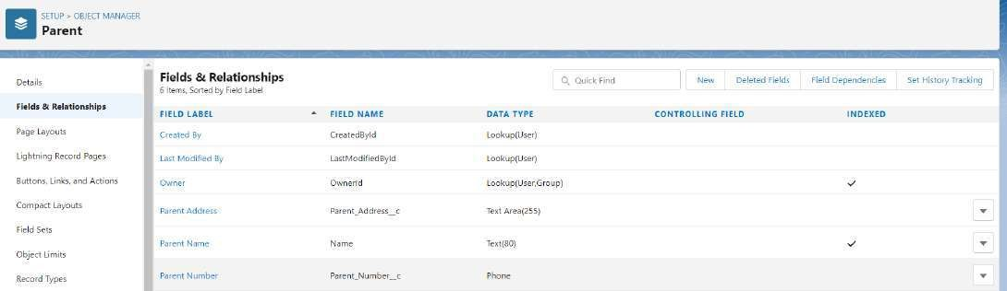

#### 6.Profile

A profile is a group/collection of settings and permissions that define what a user can do in salesforce. A profile controls “Object permissions, Field permissions, User permissions, Tab settings, App settings, Apex class access, Visualforce page access, Page layouts, Record Types, Login hours & Login IP ranges.

**Creation of Profile**:

1.From Setup enter Profiles in the Quick Find box

2.Select Profiles.

3.Click new, From the list of profiles, find Standard User (profile to clone)

4.For Profile Name, enter School Profile

5.Click Save.

6.While still on the School Profile page, then click Edit.

7.Scroll down to Custom Object Permissions and Give view all access permissions.

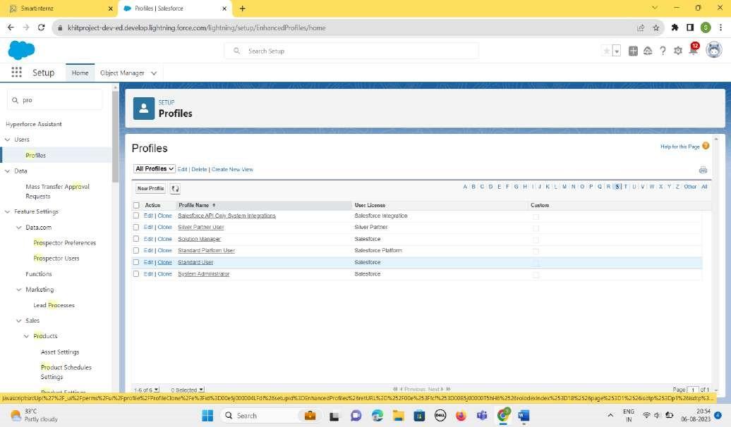

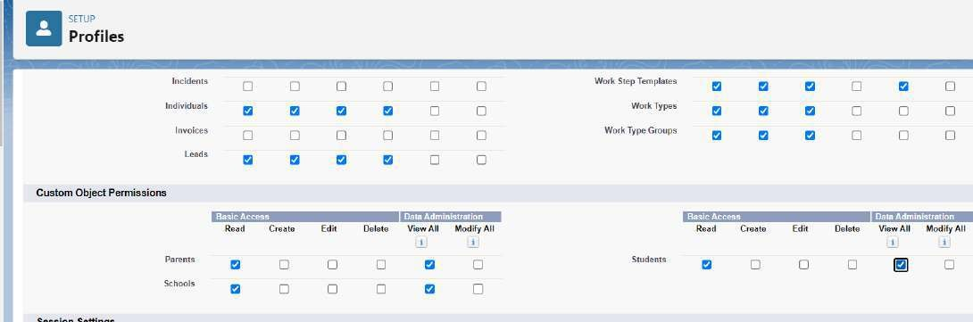

The “School Profile” is created as below:

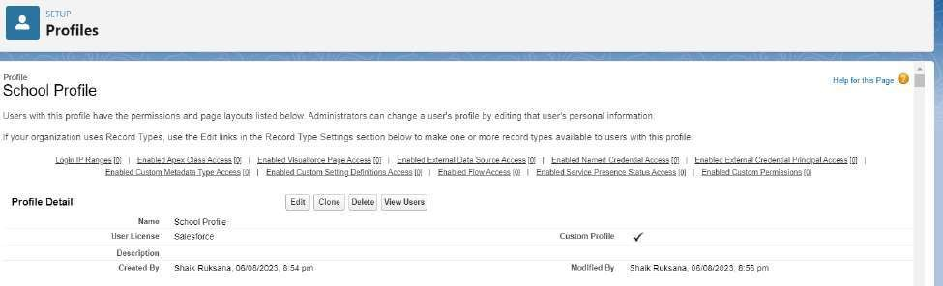

### 7.Users

A user is anyone who logs in to Salesforce. Users are employees at your company, such as sales reps, managers, and IT specialists, who need access to the company's records. Every user in Salesforce has a user account.

**Creating A User**:

1.From Setup, in the Quick Find box, enter Users.

2.Select Users.

1. Click New User.
2. Enter the user’s name Parents and (Your) email address and a unique username in the form of an email address. By default, the username is the same as the email address.
3. Select a User License as salesforce.

NOTE- As Salesforce license can only be used by 2 Users at a time in Dev Org, so If you don’t find salesforce license then deactivate a user who has salesforce license or change the license type from Salesforce to any other.

6.Select a profile as a School Profile.

1. Check Generate new password and notify the user immediately to have the user’s login name and a temporary password emailed to your email.
2. Similarly follow the above steps and create 2 users as Teachers and principals.

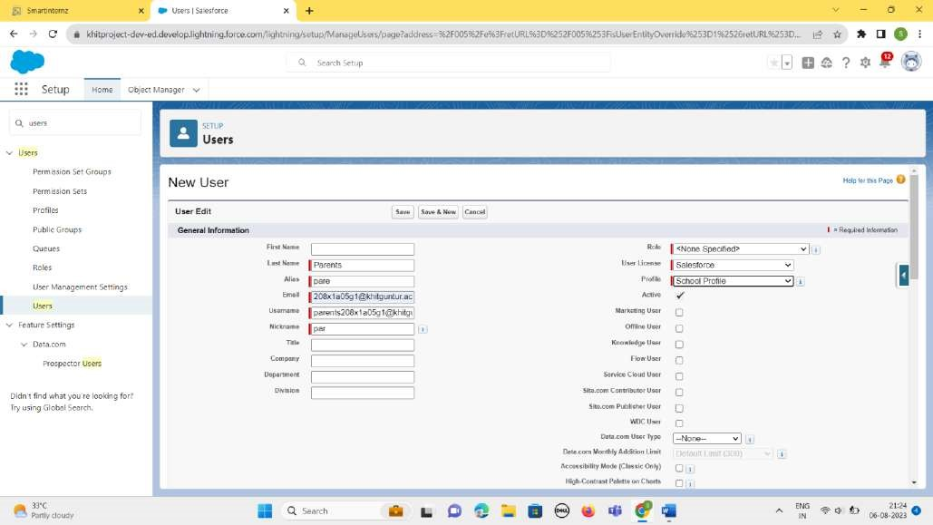

Similarly,we created two users -Teachers and Principals like below:

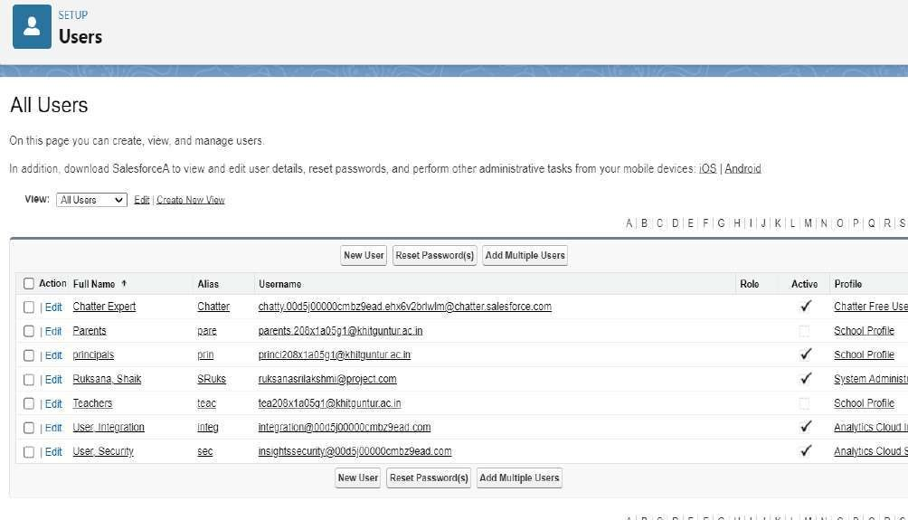

#### 8.Permission Sets

A permission set is a collection of settings and permissions that give users access to various tools and functions. Permission sets extend users' functional access without changing their profiles.

Permission Sets 1:

1.From Setup, enter Permission Sets in the Quick Find box, then select Permission Sets.

2.Click New.

3.Give the name of the Permission set name as teacher permission.

4.Under the object settings give the view create and edit permissions to all 3 custom objects (By click open the object)

5.Click on manage assignment

6.Click on add assignment.

7.Click on Teacher (user), Next, Assign.

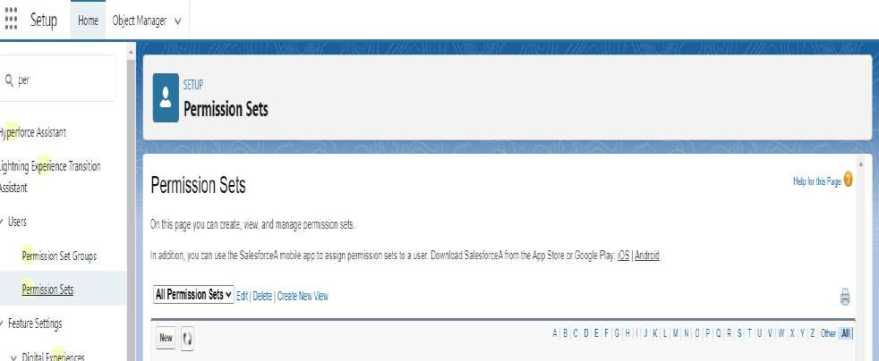

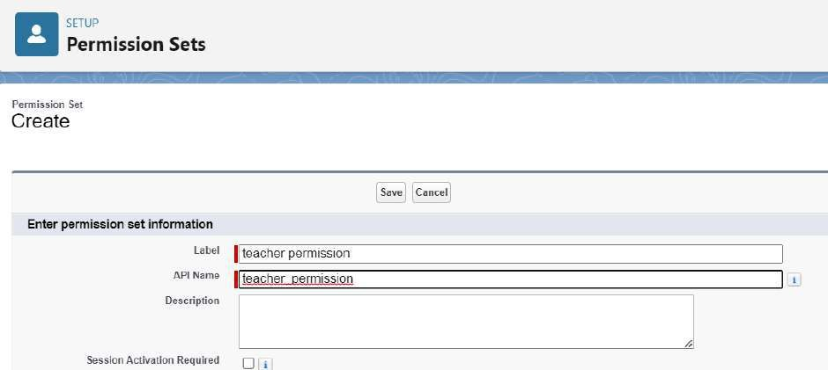

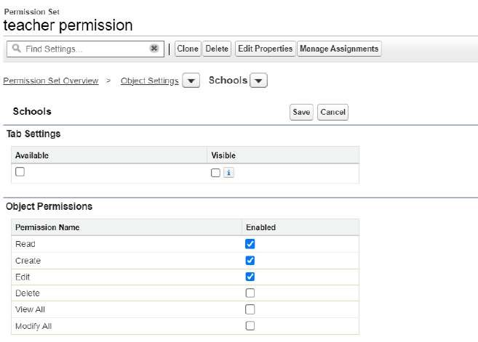

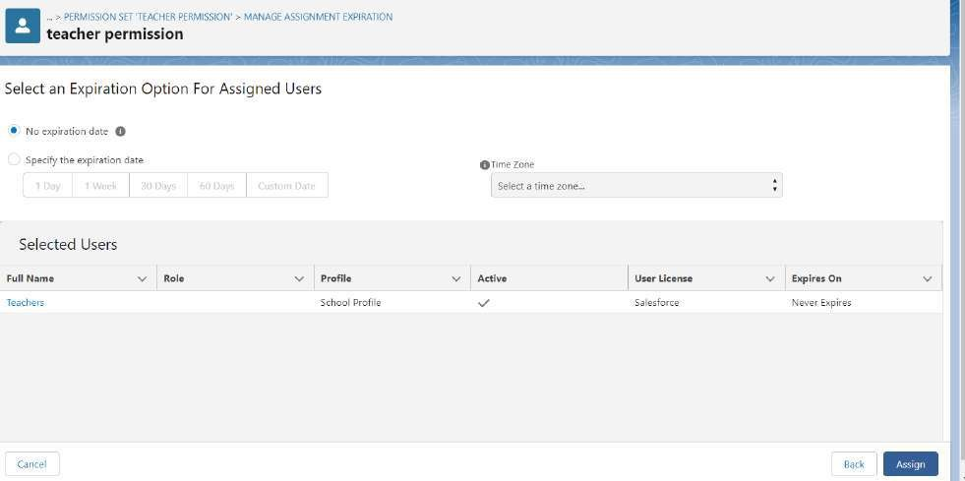

Permission Sets 2:

Similarly, we create another permission set that is Principal permission.

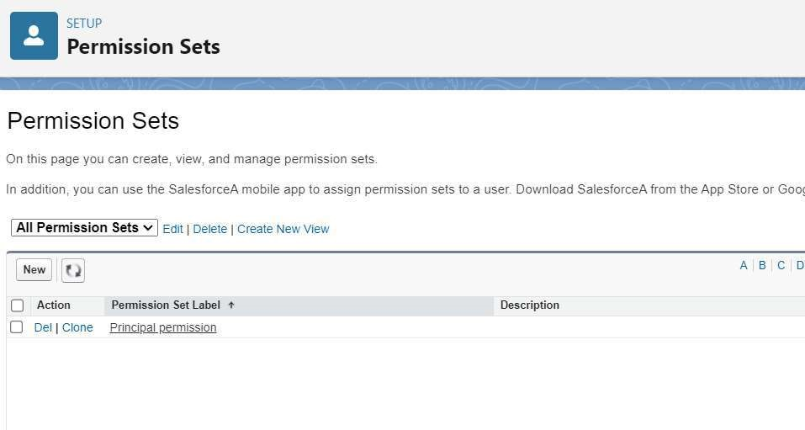

#### 9.User Adoption

**Create Record (School):**

1.Click on App Launcher on left side of screen.

2.Search School Management App & click on it.

3.Click on Schools tab.

4.Click new button

5.Fill all School record details.

6.Click on Save Button

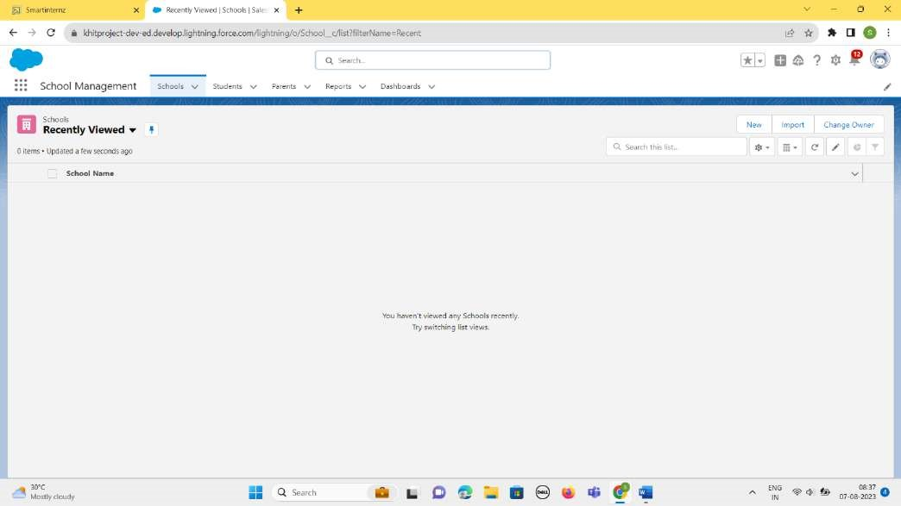

Clicking new, we have to fill the details of the school like School Name, Address, State, District, Phone Number, School Website.

This is displayed below:

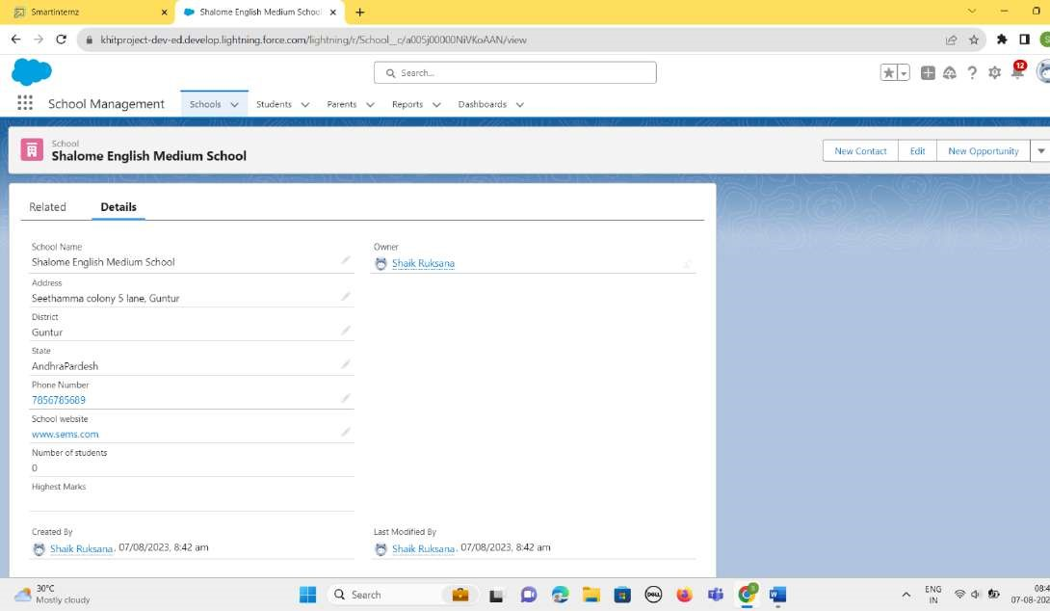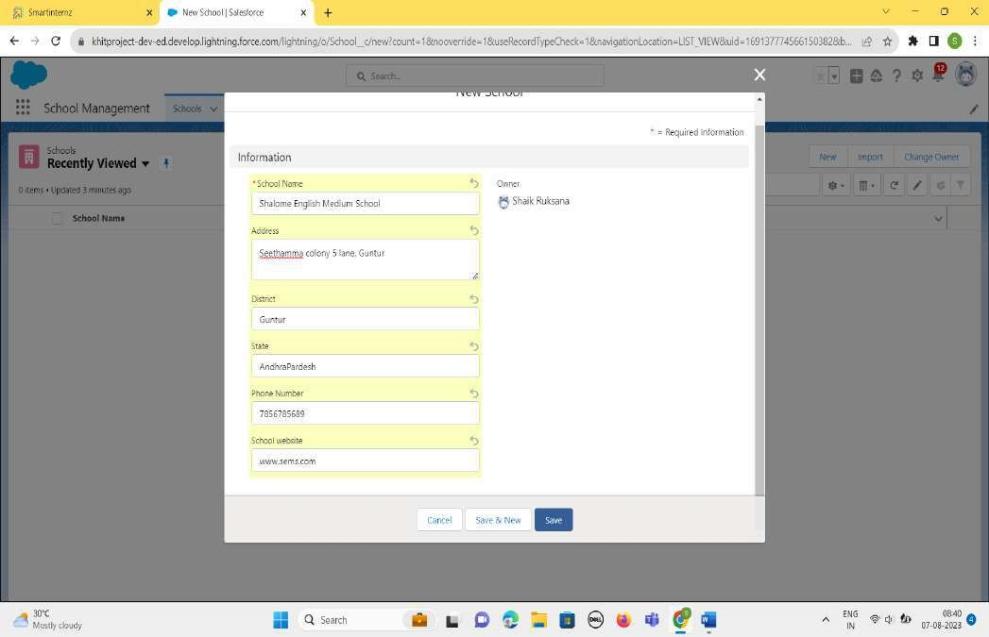

**View Record (School):**

**Delete Record (School):**

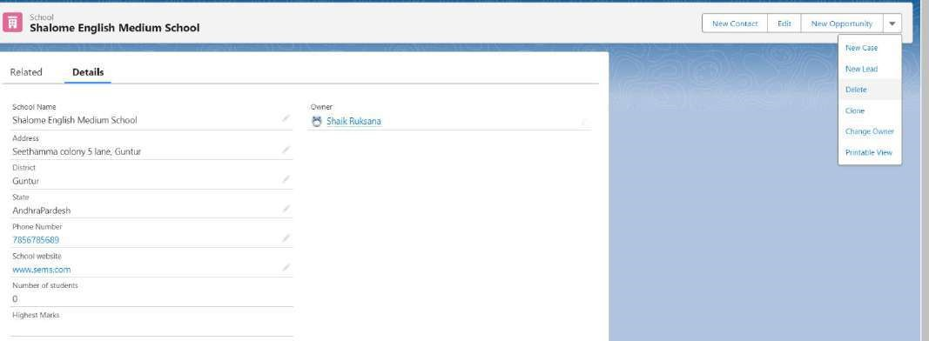

By Clicking it, The School named “*Shalome English Medium School*“ will be deleted . And it is not Visible.

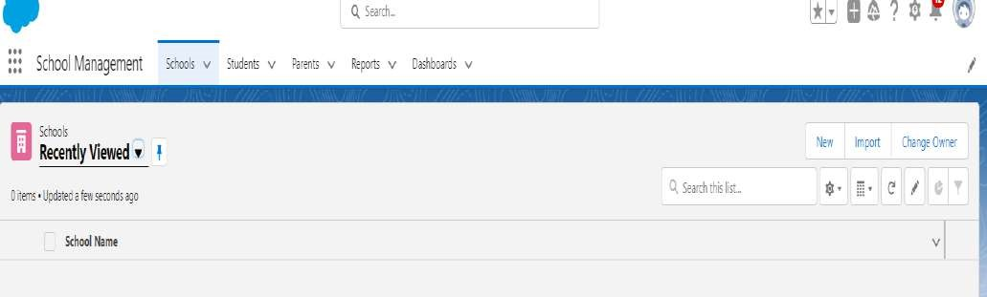

### 10.Reports

Reports in Salesforce is a list of records that meet a particular criterion which gives an answer to a particular question. These records are displayed as a table that can be filtered or grouped based on any field.

**Create Report**:

1.In School Management App click Reports tab.

2.Click New Report.

3.Select the report type as School with students and parents for the report.

4.Click start report.

5.Customize your report, then save and run

6.Give report name – Schools with Students Report

7.Click Save

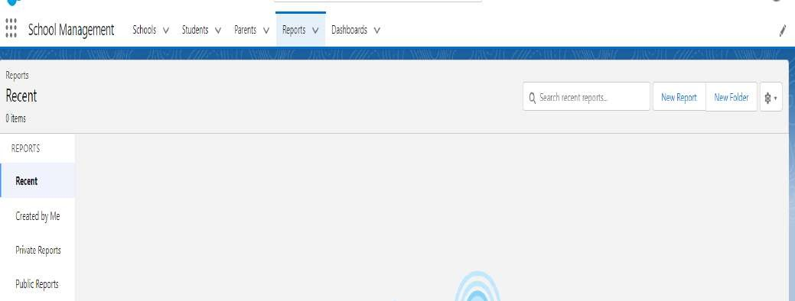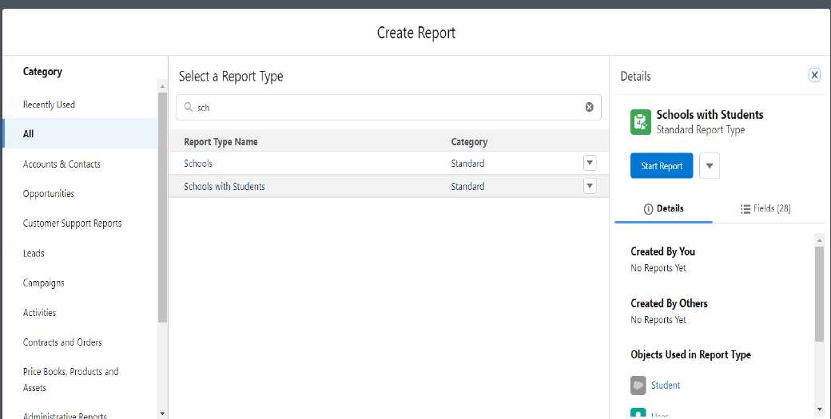

The following is the format of the Report for the school:

It contains *Outlines* and *Filters*

In Outlines tab we have- Group Rows, Group Columns.

In the Columns Tab, we have Columns like *School: School Name*, *Student: Student Name*

Now we have to save the report with the Report Name – “*Schools with Students Report”.* Click save & run at the top and save it as below:

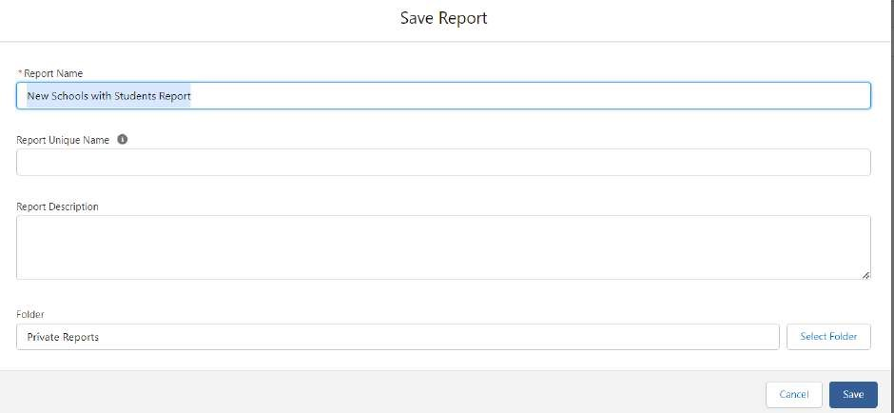

**View Report**:

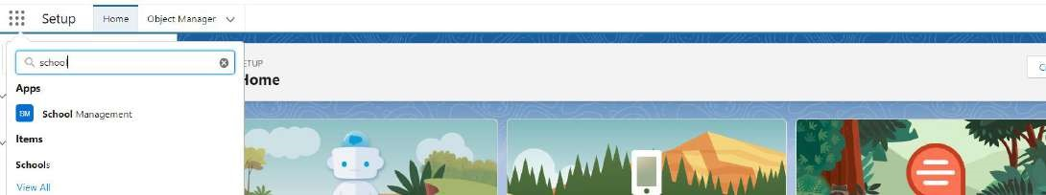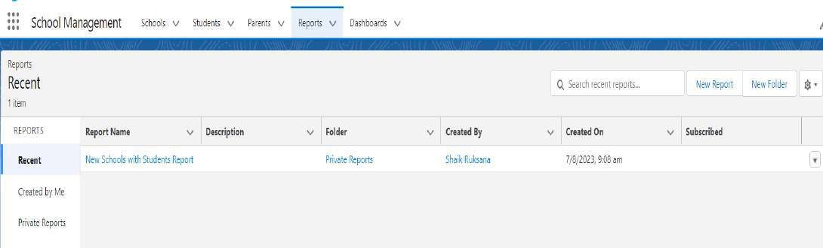

1.Click on App Launcher on left side of screen.

2.Search School Management App & click on it.

3.Click on Reports Tab.

4.Click on School with Students report and see records.

In this way, we have successfully created the *School Management App*and performed all the actions.

#### ADVANTAGES & DISADVANTAGES

**Advantages:**

1.Cloud-based: Being built on the Salesforce platform, the application enjoys the benefits of cloud computing, including scalability, flexibility, and ease of access from anywhere with an internet connection.

2.Integrated Ecosystem: Salesforce offers a wide range of native tools and integrations with third-party applications, enabling seamless integration with other school systems like HR, finance, or communication tools.

3.Customizability: Salesforce provides a highly customizable development environment, allowing the application to be tailored to the specific needs of each educational institution.

4.User-Friendly Interface: With Salesforce's focus on user experience, the application can have an intuitive and user-friendly interface, reducing the learning curve for administrators, teachers, parents, and students.

5.Security and Compliance: Salesforce maintains robust security measures and compliance standards, ensuring data privacy and protection for sensitive student and school information.

**Disadvantages:**

1.Cost: Utilizing the Salesforce platform and acquiring user licenses can be costly, especially for smaller educational institutions with limited budgets.

2.Learning Curve: Customizing and developing applications on Salesforce may require specialized skills and expertise, leading to a learning curve for administrators and developers.

3.Dependency on Salesforce: As the application is built on the Salesforce platform, there is a level of dependency on Salesforce's services and updates, which could impact the application's functionality.

4.API Limitations: The Salesforce API has usage limits, and integrating with multiple external systems may require careful planning and optimization to avoid hitting those limits.

5.Data Ownership: Storing data on a third-party platform means the school must trust Salesforce with its sensitive data, which might raise concerns about data ownership and control.

6.Offline Access: Salesforce applications heavily rely on internet connectivity, which might be a limitation in areas with unreliable or limited internet access.

7.Limited Customization in Low-Code Solutions: If the application is built primarily using lowcode solutions, there might be some limitations in customizing complex functionalities that require more sophisticated coding.

#### APPLICATIONS

1.Schools and K-12 Institutions

2.Colleges and Universities

3.Online Learning Platforms

4.Tutoring Centres and Coaching Institutes

5. Non-Profit Educational Initiatives

6.Training and Development Programs

1. Vocational Institutes
2. Special Education Programs

9.After-School Programs

10. Language Schools

##### CONCLUSION

In conclusion, the School Management Application developed on the Salesforce platform offers a comprehensive and efficient solution to streamline administrative tasks and improve communication within educational institutions. Through a user-friendly interface and automation features, the application simplifies attendance tracking, academic management, and examination processes.

##### FUTURE SCOPE

The School Management Application in Salesforce has a promising future scope, with several potential enhancements and improvements that can be implemented to further enhance its functionality and impact. Some future enhancements include:

*1.Mobile Application*: Develop a dedicated mobile application for the school management system, allowing users to access important information and perform essential tasks on their smartphones or tablets for greater convenience and flexibility.

*2.Artificial Intelligence Integration*: Integrate AI capabilities into the application to provide intelligent insights and recommendations, such as personalized learning paths for students or predictive analytics for student performance.

*3.Learning Management System (LMS) Integration*: Integrate with popular Learning Management Systems to streamline the delivery of online coursesand assignments, providing a comprehensive solution for blended and remote learning.

*4.Parent-Teacher Conference Scheduling*: Implement a feature that allows parents to schedule and manage parent-teacher conferences directly through the application, reducing administrative overhead and improving parent-teacher communication.

*5.Alumni Management*: Extend the application to include an alumni management module, enabling schools to maintain relationships with former students, conduct alumni events, and seek support for various initiatives.

*6.Financial Aid and Scholarship Management*: Introduce a module to manage financial aid and scholarship applications, making it easier for students to apply and for administrators to track and disburse awards.

*7.Classroom IoT Integration*: Explore integrating IoT devices in classrooms for smart attendance tracking, environmental monitoring, and other data collection to enhance teaching and learning experiences.

*8.Gamification and Rewards*: Introduce gamification elements to incentivize positive behaviours and academic achievements among students, fostering a more engaging and rewarding learning environment.

*9.Virtual Reality (VR) and Augmented Reality (AR) Support*: Explore VR and AR integration for immersive learning experiences and virtual field trips, making education more interactive and engaging.

*10.Predictive Analytics for Student Success*: Develop predictive analytics models that can identify at-risk students and provide timely interventions to improve retention and academic success.

*11.Multilingual Support*: Enable multilingual support in the application to cater to diverse language preferences, especially in international schools and institutions.

12*.Voice Assistant Integration*: Introduce voice-activated assistants to enable users to interact with the application using voice commands, making it more accessible and userfriendly.

# *THANK YOU*

Our Trailblazer accounts

*Name Profile*

1.Shaik Ruksana - <https://www.salesforce.com/trailblazer/s208x1a05g1>

2.Balineni Srilakshmi - <https://www.salesforce.com/trailblazer/s208x1a05c8>

3.Kambhampati Akhil - <https://www.salesforce.com/trailblazer/akambhampati5>

4.Maddu Ramya - <https://www.salesforce.com/trailblazer/s208x1a05f2>

5.Chalamalasetty Keerthana - <https://trailblazer.me/id/s208x1a05d61>

6.Rentapalla Vamsi - <https://www.salesforce.com/trailblazer/s218x5a0208>

